

Blue Shield of California
Web Messaging Project

Technical Design Specification
V 7.00

Prepared by:
Ross Hartford
June 19, 2026


Table of Contents
Web Messaging Deployment 5
About Web Messaging 5
Genesys Configuration Items 6
Web Messenger 6
Web Messenger Configuration Options 7
Web Messenger Deployment Options For Member Portal 8
Web Messenger Sample JavaScript 8
Web Messenger Deployment Options For Sierra Integration 8
Web Messenger Sample JavaScript 9
Web Messenger Sample UI 9
Schedules 11
Schedule Groups 11
Skills 12
Emergency Groups 13
Division 14
Genesys Queues 14
Queue Definitions 14
Data Table Layout 15
Queue Lookup 16
Agent Utilization 16
REST API Integration 18
Member Experience Process Diagram 18
GCX API URL 19
Authentication 19
Making Requests to GCX 19
Write Data to Genesys Data Table 19
Data Table GUID Retrieval 19
Write Data Table Row for Member Data 20
Data Table Cleanup 22
Daily Cleanup Job 22
End of Chat Cleanup 22
Get Queue Statistics Data 22
Get Queue ID 22
Get Queue Statistics 25
Get Schedule Group ID 29
HTTP Request 29
JSON Input 29
JSON Output 29
Get Schedule(s) 31
HTTP Request 31
JSON Input 31
JSON Output 31
Medicare Sales 33
Questions: 33
BUSINESS CONTEXT 33
Requirements 34
Transfers 36
Data collection During Hours 36
Afterhours Processing 37
Web Portal Integration 37
Web Messenger Sample JavaScript 37
Acceptance Criteria 39
Unavailability 39
Chat and Call Management 39
Chat Trigger 41
Queue Management 41
Bulk Scheduled Trigger/Queue Activation Process Automation 42
Technical Solution Specifics 43
Member Queue Management 43
Data Table 43
Workflows 44
Scheduled Triggers 45
Web Messaging 47
Data Actions 47
Data Tables 48
Callflows 48
Callflow Usage 49

Modification History
Modification Date | Modified By | Description | Version
09/13/2023 | Ross Hartford | Initial Draft | 1.0
09/15/2023 | Diane Halliwell | Internal review | 1.0
09/15/2023 | Ross Hartford | Final review before delivery | 2.0
09/18/2023 | Ross Hartford | Delivery | 2.0
10/16/2023 | Ross Hartford | Updated to remove authenticated messaging | 2.5
10/20/2023 | Ross Hartford | Update to add Java SDK functions to each API. Include stats for the queue query | 3.0
11/29/2023 | Ross Hartford | Updated with changes during build | 3.1
11/30/2023 | Ross Hartford | Updated with new group, plan type and language data table info | 3.2
12/6/2023 | Ross Hartford | Add estimated wait time API | 3.4
02/29/2024 | Ross Hartford | Add Medicare Chat information | 3.5
04/06/2026 | Ross Hartford | Add Provider / Broker information | 4.0
05/15/2026 | Ross Hartford | Add Sierra Information | 5.01
06/11/2026 | Ross Hartford | Add Medicare Sales information | 6.00
06/18/2026 | Jason Rottero | Add Scheduled Trigger/Queue Activation Process Automation | 7.00
06/19/2026 | Ross Hartford | Add flow information | 7.00

Web Messaging Deployment
Blue Shield (BSC) is deploying the Genesys Web Messaging application for certain member segments. The unauthenticated method of deployment will be used as the interface to Genesys.
A REST interface from the web server to GCX will be required. The requests that will be required are:
- Data Table write – This will pass the data from the web server to GCX to a GCX data table for storage. A GUID will be used to index the data to the member’s session.
- Agent Staffing – This API will be used to determine if agents are logged into the queue for web messaging. The number of sessions in queue can also be determined.
- .
The interface to the member browser will be deployed via a JavaScript API. The GUID stored above will be passed as user data in the JavaScript API. The GCX routing callflow will retrieve the attributes from the data table and pass those to the agent desktop via GCX Participant Data.

About Web Messaging
Genesys provides detailed information about the deployment of Web Messaging at: https://help.usw2.pure.cloud/articles/about-web-messaging/.

Genesys Configuration Items
The following items will be configured in GCX in support of the Web Messaging deployment.

Web Messenger
Messenger provides a predefined message window and launcher button which customers use to interact with bots and agents. Administrators can easily configure and deploy a standardized implementation of Messenger in the Genesys Cloud Admin UI. To get started:
- Configure Messenger. Create a configuration to define the appearance and behavior of the message window.
- Deploy Messenger. Create a Messenger deployment and assign a version of a Messenger configuration to generate the snippet.
- Deploy JavaScript Snippet. Deploy the Messenger snippet to your website.
- Schedule Group – Controls the operating hours of the messaging contact center
- Schedule – Defines the operating hours and holidays available to be included in the Schedule Group
- Skills – The skills required for delivery of a chat to an agent
- Emergency Groups – Allows for the capability to immediately close the contact center web messaging queue for an emergency or a meeting.
- Division – Authorization entity within Genesys Cloud to control the access to configured GCX objects.
- Queue – Routing entity to determine when agent should receive an inbound chat.

Web Messenger Configuration Options
The following options will be configured for the Web Messenger configuration for Member, Provider, and Broker:
Section | Option | Value
Messenger Behavior | Set your Launcher Button Visibility | Hide until triggered by business logic.
 | User Interface | On
 | Messenger Homescreen | On
Customize your Messenger Appearance | Humanize your Conversation | On
 | Bot Name | Live Chat
 | Messenger Color | #003B5C
 | Messenger Position | Auto
 | Side Spacing | 20 px
 | Bottom Spacing | 12 px
Labels & Language Support | Supported Languages | English, Spanish
 | Default Language | English
 | Homescreen Header – Line 1 | Welcome to Blue Shield of California Live Chat!
 | Homescreen Header – Line 2 | .
Apps | Conversation Disconnect | Display conversation status and disconnect session
 | Rich Text Formatting | On
 | Automatically Start Conversations | On
 | Attachments | Off
 | Typing Indicators | On
 | Inform agent when the end-user is actively replying. | On
 | Enable an agent to view a customer's screen | On
 | Enable an agent to request to take control of a customer's screen | On
 | CSS Masking | N/A
 | CSS Read-only | N/A
 | Authentication | Off
 | Predictive Engagement | Off

Web Messenger Deployment Options For Member Portal
The following options will be configured for the Web Messenger configuration:
Section | Option | Value
Messenger Deployment | Name | BSCWebMessagingPOC - Unauthenticated
 | Description | Blue Shield of CA web messaging deployment
 | Status | Active
 | Restrict Domain Access | Allow All Domains
 | Architect Flow | BSCWebMessaging
 | Deployment Key – DEV
 | Deployment Key – PROD

Web Messenger Sample JavaScript
A unique JavaScript code snippet will be generated once the web messaging configuration is completed. Below is a sample of a non-authenticated messaging implementation. The “Database.set” function must be used to pass the generated GUID that identifies the member data to Genesys. This is not a part of the default JavaScript snippet and must be added to the code.
<script type="text/javascript" charset="utf-8">
(function (g, e, n, es, ys) {
g['_genesysJs'] = e;
g[e] = g[e] || function () {
(g[e].q = g[e].q || []).push(arguments)
};
g[e].t = 1 * new Date();
g[e].c = es;
Genesys("command", "Database.set", { messaging: { customAttributes: { GUID: GeneratedSessionGUID}});
ys = document.createElement('script'); ys.async = 1; ys.src = n; ys.charset = 'utf-8'; document.head.appendChild(ys);
})(window, 'Genesys', 'https://apps.usw2.pure.cloud/genesys-bootstrap/genesys.min.js', {
environment: 'usw2',
deploymentId: TBD'
});
</script>

Web Messenger Deployment Options For Sierra Integration
The following options will be configured for the Web Messenger configuration:
Section | Option | Value
Messenger Deployment | Name | Sierra Chat Integration
 | Description | Blue Shield of CA web messaging deployment for Sierra integration
 | Status | Active
 | Restrict Domain Access | Allow All Domains
 | Architect Flow | BSCWebMessaging_V06
 | Deployment Key - DEV
 | Deployment Key - Prod

Web Messenger Sample JavaScript
A unique JavaScript code snippet will be generated once the web messaging configuration is completed. Below is a sample of a non-authenticated messaging implementation. The “Database.set” function must be used to pass the generated GUID that identifies the member data to Genesys. This is not a part of the default JavaScript snippet and must be added to the code.
<script type="text/javascript" charset="utf-8">
(function (g, e, n, es, ys) {
g['_genesysJs'] = e;
g[e] = g[e] || function () {
(g[e].q = g[e].q || []).push(arguments)
};
g[e].t = 1 * new Date();
g[e].c = es;
Genesys("command", "Database.set", { messaging: { customAttributes: { GUID: GeneratedSessionGUID}});
ys = document.createElement('script'); ys.async = 1; ys.src = n; ys.charset = 'utf-8'; document.head.appendChild(ys);
})(window, 'Genesys', 'https://apps.usw2.pure.cloud/genesys-bootstrap/genesys.min.js', {
environment: 'usw2',
deploymentId: TBD'
});
</script>

Web Messenger Sample UI
Based on the configuration determined during the demo phase of the engagement, the UI will appear as shown below:

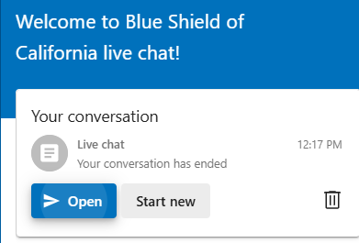

Schedules
Schedules are used for common definitions of time, which are then applied to multiple groups under multiple circumstances. A schedule stipulates when a flow runs, based upon the date, time, or event. You can define schedules to handle recurring events, holidays, or special situations, such as your regular business hours or after-hours support.
Schedule Name | Hours of Operation | Days of Week
WebMessaging_BSC | 08:30 – 15:00 | Mon - Fri
WebMessaging_Medicare | 08:30 – 16:30 | Mon – Fri
WebMessaging_Provider | 06:00 – 18:30 | Mon – Fri
WebMessaging_Broker | 08:00 – 18:00 | Mon – Fri
WebMessaging_MedicareSalesTriage | 09:00 – 16:00 | Mon – Fri
WebMessaging_MedicareSalesAgent | 09:00 – 16:00 | Mon – Fri

Schedule Groups
Defining and managing schedules can be cumbersome. To help with this process, the design uses schedules with schedule groups to allow more flexibility in how your organization manages routing hours. Schedules are the blocks of time for which an interaction route is selected. Schedule Groups allow you to combine multiple schedules and associate them with a single schedule definition. You can assign the schedules into a designated time zone and group them by type. Schedule types are limited to Open Hours, Closed Hours, or Holiday.
Schedule Group Name | Schedules |  | Holidays
WebMessaging_BSC | WebMessaging_BSC | HOL_New Year Day  HOL_MLK  HOL_PresidentsDay  HOL_MemorialDay  HOL_Juneteenth  HOL_IndependenceDay  HOL_LaborDay  HOL_Thanksgiving  HOL_DayAfterThanksgiving  HOL_Christmas  Hol – Christmas Eve Observed
WebMessaging_Medicare | WebMessaging_Medicare |  | HOL_Thanksgiving  HOL_Christmas
WebMessaging_Provider | WebMessaging_Provider |  | TBD
WebMessaging_Broker | WebMessaging_Broker |  | HOL_New Year Day  Hol – Easter  Hol – Memorial Day  Hol – Juneteenth 8a-5p  Hol – labor day  Hol – Thanksgiving day  Hol – Day After Thanksgiving day  Hol – ChristmasEve 8a-3p  Hol – Christmas day
WebMessaging_MedicareSalesTriage | WebMessaging_MedicareSalesTriage |  | HOL_Christmas  HOL_IndependenceDay  HOL_Juneteenth  HOL_LaborDay  HOL_MemorialDay  HOL_Thanksgiving

Skills
The following skills will be created in Genesys:
Skill Name | Skill Type
English | Language
Spanish | Language
Chat_Other_Benefits | ACD Skill
Chat_Change_PCP | ACD Skill
Chat_None_of_These | ACD Skill
Chat_Website | ACD Skill
Chat_ID_Cards_Plan_Documents | ACD Skill
Chat_Referrals_Authorizations | ACD Skill
Chat_Bill_Payments | ACD Skill
Chat_Claims | ACD Skill
Chat_Appointments | ACD Skill
Chat_Find_a_Doctor | ACD Skill
Provider_BlueCard_Facility_Claims | ACD Skill
Provider_Commercial_Claims | ACD Skill
Provider_Promise_Claims | ACD Skill
Provider_Medicare_Claims | ACD Skill
Provider_BlueCard_Professional_Claims | ACD Skill
Provider_Share_Advantage_Claims | ACD Skill
Provider_Commercial_Claims | ACD Skill
Provider_Commercial_NonClaims | ACD Skill
Provider_Promise_NonClaims | ACD Skill
Provider_Medicare_NonClaims | ACD Skill
Provider_Shared_Advantage_NonClaims | ACD Skill
Provider_Provider_Information_And_Enrollment | ACD Skill
Provider_Electronic_Data_Interchange | ACD Skill
Provider_Corporate_Recoveries | ACD Skill
Broker_Individual_Family_Plan_Tier_1 | ACD Skill
Broker_Individual_Family_Plan_Tier_2 | ACD Skill
Broker_Individual_Family_Plan_Tier_3 | ACD Skill
Broker_Large_Group_Tier_3 | ACD Skill
Broker_My_Broker_Account_Tier_3 | ACD Skill
Broker_Senior_Markets_Tier_1 | ACD Skill
Broker_Senior_Markets_Tier_2 | ACD Skill
Broker_Senior_Markets_Tier_3 | ACD Skill
Broker_Small_Business_Tier_1 | ACD Skill
Broker_Small_Business_Tier_2 | ACD Skill
Broker_Small_Business_Tier_3 | ACD Skill
Chat_MedicareSales

Emergency Groups
An emergency group can be created and associated with a group in the routing engine to quickly and efficiently turn on routing functionality that modifies call routing behavior during unplanned or semi-planned critical events, such as fire, natural disasters, and power outages. Use the activate and deactivate feature to test functionality prior to an actual emergency.
To manage emergency groups for the organization, click Admin. Under Routing, click Emergencies. On the Emergencies page, you can view the list of active and inactive emergency groups and their related routing.
The following Emergency Groups will be created in Genesys:
Emergency Group Name
WebMessaging_BSC
WebMessaging__Medicare
WebMessaging_Provider
WebMessaging_Broker
WebMessaging_MedicareSalesTriage

Division
In Genesys Cloud, administrators can separate and group configuration objects into separate divisions. A division is a way to group and segregate objects but keep them inside the same organization. For example, you can create divisions by business units, countries, and office locations and then assign configuration objects to each division. After you create and configure divisions, you can use roles to grant user access to divisions, and thus the objects within each division.
Notes:
- An organization can create up to 50 divisions.
- Division names are limited to 500 characters.
- You can view user and queue information in certain views, regardless of division restrictions.
Division Name | Description
CustomerExperience | Customer Experience
ProviderQueues | Provider queues
BrokerQueues | BrokerQueues

The division will contain these object types that are in use by web messaging:
- Queues

Genesys Queues
Queues are the “waiting lines” of interactions. Agents select the On Queue status to enter their predefined queues. Contact center queue settings include creating and managing queues for voice and chat channels for the entire organization.
- An organization can add up to 5000 queues.
- Membership is limited to 5000 members per queue.
- Each queue name must be unique. You cannot duplicate a queue name.
- A queue name cannot contain asterisks.

Queue Definitions
The following Genesys Queues will be defined for routing of web messaging interactions to agents.
Genesys Queue Name
WebMessaging_BSC
WebMessaging_Medicare
WebMessaging_Broker
WebMessaging_Provider
WebMessaging_MedicareSalesTriage
WebMessaging_MedicareSalesAgent

Data Table Layout
The following data will be sent from the Member Portal to the Genesys CX environment. It will be retrieved by the callflow and placed into GCX Participant Data keys / values for use by Pega. The GCX Data Table will be named “BSCWebMessagingData”.
Participant Data Name | Maximum Length | Definition
GUID (key) | 36 | The GUID / UUID to identify the member data. It is generated by the portal service
TFN | 10 | The toll-free number for the customer to call customer care for their group.
AlphaPrefix | 4 | Alpha prefix of the member’s active policy
SubID | 9 | Subscriber ID
MemberSuffix | 2 | Member suffix for the logged in user
DOB | 8 | Date of birth of the logged in user Format is MMDDYYYY
Group | 8 | Group Number  Ex: X0001004 or W0002935
PlanType | 15 | Plan type of the member’s active plan  Ex: PREMIER, CORE, IFP, or SMALL_GROUP
TaskValue | 3 | Set this value to 500 for all data
Language | 4 | Language code for the member’s preferred language.  EN01 = English  SP01 = Spanish  MN01 = Mandarin  VI01 = Vietnamese
SystemType | 1 | Always “G” for Genesys
EmailAddress | 128 | Email address of the logged in user
FirstName | 50 | First name of logged in user
LastName | 50 | Last name of logged in user
PhoneNumber | 11 | Members preferred contact number
Web_InteractionType | 1 | M or empty – Member  P – Provider  B – Broker  S - Sierra
Web_EntityId |  | Broker or Provider ID from portal
Product_ID |  | Product Id – Comma separated list of products associated with the subscriber

Queue Lookup
This data table is used to determine the queue for the session.
Queue Lookup Key | Queue Name
W0002935 | WebMessaging_BSC
W0051448 | WebMessaging_BSC
W0051752 | WebMessaging_Medicare
W0064559 | WebMessaging_BSC
W8000003 | WebMessaging_BSC
X0001000 | WebMessaging_BSC
X0001004 | WebMessaging_BSC
Provider | WebMessaging_Provider
Broker | WebMessaging_Broker
Sierra | WebMessaging_BSCEmployees
MedicareSales | WebMessaging_MedicareSalesTriage

Agent Utilization
Agent utilization indicates the maximum number of concurrent interactions that Genesys Cloud ACD can assign to an agent. Interactions include voice (calls), chats, emails, messages, and callbacks. By default, an agent can handle one interaction:
- One call
- Up to four chats
- One email
- One message
- One callback
Agent utilization is configurable at the organization and at the agent level. An administrator can specify the maximum number of interactions that agents handle simultaneously for each interaction type. Administrators can also designate the interaction types that can interrupt, or alert, agents who handle other interaction types. For example, if an agent is working on an email, then Genesys Cloud can alert the agent to answer an incoming call. To ensure agents who are actively handling customer calls do not receive alerts for messages or other interaction types, do not allow interruptions to voice interactions. By default, Genesys Cloud allows interruptions to email. The system does not include non-ACD calls in the overall ACD utilization count because they are considered internal, not ACD calls.

REST API Integration
The following REST APIs will be used by web messaging services to interact with the Genesys environment. These APIS are used to pass the member data securely and to determine if the web messaging group is open.
Purpose | HTTP Method | API Endpoint
Retrieve data table GUID | GET | /api/v2/flows/datatables/divisionviews
Write data to Genesys data table | POST | /api/v2/flows/datatables/{datatableId}/rows
Get Queue GUID | GET | /api/v2/routing/queues
Get queue statistics | POST | /api/v2/analytics/queues/observations/query
Get schedule group ID | GET | /api/v2/architect/schedulegroups/divisionviews
Get Schedule Group | GET | /api/v2/architect/schedulegroups/{scheduleGroupId}
Get Schedule | GET | /api/v2/architect/schedules/{scheduleId}

Member Experience Process Diagram
This diagram depicts the integration between the member portal and Genesys Cloud.
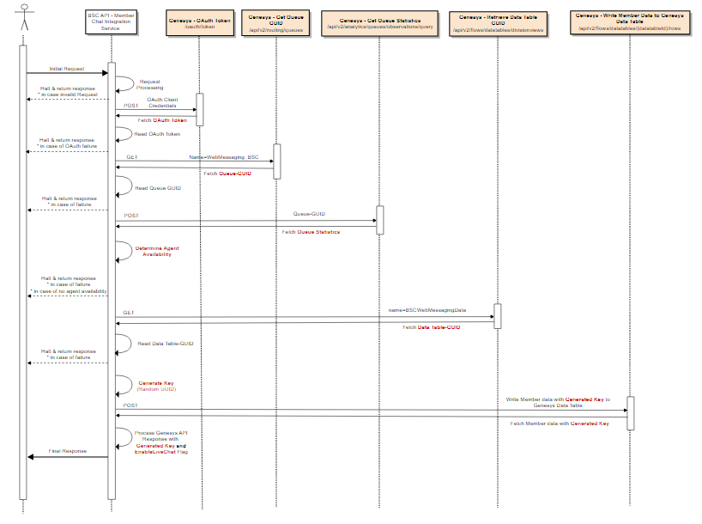

GCX API URL
All API requests will be sent to https://api.usw2.pure.cloud.
For Java SDK integration, the host name will be usw2.pure.cloud.

Authentication
The authentication to GCX will be via a Client Credentials Grant. This is used for a “non-human” interface to Genesys, such as a web server. Details about authentication can be found at https://developer.genesys.cloud/devapps/sdk/java#authenticating and https://developer.genesys.cloud/authorization/platform-auth/

Making Requests to GCX
Details on making API requests to GCX via .Java can be found at https://developer.genesys.cloud/devapps/sdk/docexplorer/purecloudjava/. Please review this web page for the methods used to authenticate to Genesys Cloud and the necessary classes to import for each request.

Write Data to Genesys Data Table
The GCX Data Table will be named “BSCWebMessagingData”. This API is used to place data about the member into the data table for retrieval by the routing callflow. The table is indexed by a GUID that will be submitted as a part of the JavaScript API from the member’s session. This allows the sensitive data to be sent via a secure method and associated with the web messaging session by GCX.
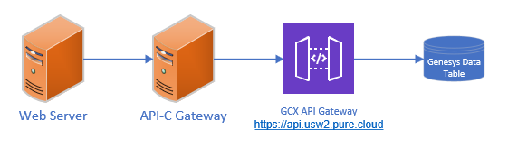
Two API calls are required to write the data to the data table. The first one retrieves the ID of the BSCWebMessagingData Data Table. This ID is then used in the second API to write the data to the Data Table.

Data Table GUID Retrieval
This API is used to retrieve the internal ID of the Data Table BSCWebMessagingData. This ID is used in the next API to write the member data row.

HTTP Request
GET /api/v2/flows/datatables/divisionviews?&pageNumber=1&pageSize=100&sortBy=name&name=BSCWebMessagingData HTTP/1.1
Host: api.usw2.pure.cloud
Authorization: Bearer **************************************************************************************
Content-Type: application/json

JSON Input
N/A

JSON Response
Response:
{
"entities": [
{
"id": "45a33905-9555-4c42-a1c2-8d6d053cb86d",
"name": "BSCWebMessagingData",
"division": {
"id": "ef31aa37-0772-4af6-bbc1-866fad16e9ec",
"name": "Home",
"selfUri": "/api/v2/authorization/divisions/ef31aa37-0772-4af6-bbc1-866fad16e9ec"
},
"selfUri": "/api/v2/flows/datatables/45a33905-9555-4c42-a1c2-8d6d053cb86d"
}
],
"pageSize": 100,
"pageNumber": 1,
"total": 1,
"pageCount": 1
}

Write Data Table Row for Member Data
This API is used to write the member data to the Data Table. The ID retrieved in the previous API is used as a part of the URI to direct the data to the correct Data Table. The individual columns in the Data Table are passed as a JSON object with the key names and data organized as shown below. See the Data Table Layout section above for details of the required columns. The “key” column in the data is the GUID assigned by the servlet to the member’s portal session. This will be used by GCX routing to attach the data to the session internally and present it to an agent.
It is required that if the write to the Data Table is not successful, then the web messaging (chat) button must not be enabled for the member to use.

HTTP Request
POST /api/v2/flows/datatables/45a33905-9555-4c42-a1c2-8d6d053cb86d/rows HTTP/1.1
Host: api.usw2.pure.cloud
Authorization: Bearer **************************************************************************************
Content-Type: application/json

JSON Input
{
"Group": "001",
"FirstName": "First",
"SystemType": "G",
"MemberSuffix": "00",
"EmailAddress": "memberemail@domainl.com",
"SubID": "123456789",
"Language": "01",
"DOB": "20230101",
"PlanType": "LG",
"PhoneNumber": "3415551212",
"LastName": "Last",
"AlphaPrefix": "XEK",
"TFN": "18005551212",
"key": "a6104434-27a6-46d7-87c1-b8bb3b566023",
"TaskValue": "500",
“Web_InteractionType”:”M”
“Web_EntityId”:”123456789”,
“Product_ID”: “M12345”
}

JSON Output
{
"Group": "001",
"FirstName": "First",
"SystemType": "G",
"MemberSuffix": "00",
"EmailAddress": "memberemail@domainl.com",
"SubID": "123456789",
"Language": "01",
"DOB": "20230101",
"PlanType": "LG",
"PhoneNumber": "3415551212",
"LastName": "Last",
"AlphaPrefix": "XEK",
"TFN": "18005551212",
"key": "a6104434-27a6-46d7-87c1-b8bb3b566023",
"TaskValue": "500"
“Web_InteractionType”:”M”
“Web_EntityId”:”123456789”,
“Product_ID”: “M12345”
}

Data Table Cleanup

Daily Cleanup Job
A daily job will be executed using the Genesys Cloud CLI to delete all rows from the Data Table. This will ensure that the maximum size of the data table is not reached. Details about the installation of the Genesys Cloud Platform CLI can be found at https://developer.genesys.cloud/devapps/cli/. This job should be scheduled on a server in the Blue Shield environment and executed daily.

End of Chat Cleanup
Genesys has the capability to trigger actions after an interaction is completed (https://help.genesys.cloud/articles/about-triggers/). A trigger will be implemented when an interaction ends ACW. This trigger will receive the original conversation id of the inbound messaging session. The workflow associated with the trigger will retrieve the GUID from the original conversation. This GUID is the “key” to the BSCWebMessagingData data table in Genesys. The workflow will then execute a data action to delete this row from the data table. The nightly cleanup will still be executed to clean up any extraneous records from the data table.

Get Queue Statistics Data
These API’s are used to determine the status of agents assigned to the BSCWebMessagingData queue. Agents that are in the status of AVAILABLE or INTERACTING indicate that the queue is staffed.

Get Queue ID
This API will retrieve the internal id of the BSCWebMessaging queue. This id is used as input to the get queue statistics API.

HTTP Request
GET /api/v2/routing/queues?pageNumber=1&pageSize=100&name=WebMessaging HTTP/1.1
Host: api.usw2.pure.cloud
Authorization: Bearer **************************************************************************************
Content-Type: application/json

JSON Input
N/A

JSON Output
{
"entities": [
{
"id": "e366f0d8-d992-411f-886e-5daad2f07b70",
"name": "WebMessaging",
"division": {
"id": "ef31aa37-0772-4af6-bbc1-866fad16e9ec",
"name": "Home",
"selfUri": "/api/v2/authorization/divisions/ef31aa37-0772-4af6-bbc1-866fad16e9ec"
},
"dateCreated": "2023-04-25T16:28:27.963Z",
"dateModified": "2023-09-05T18:46:27.774Z",
"modifiedBy": "6c74e21f-7d65-4b0e-b16a-326d3aba09ba",
"createdBy": "6c74e21f-7d65-4b0e-b16a-326d3aba09ba",
"memberCount": 6,
"userMemberCount": 6,
"joinedMemberCount": 6,
"mediaSettings": {
"call": {
"alertingTimeoutSeconds": 8,
"serviceLevel": {
"percentage": 0.8,
"durationMs": 20000
}
},
"callback": {
"alertingTimeoutSeconds": 30,
"serviceLevel": {
"percentage": 0.8,
"durationMs": 20000
}
},
"chat": {
"alertingTimeoutSeconds": 30,
"serviceLevel": {
"percentage": 0.8,
"durationMs": 20000
}
},
"email": {
"alertingTimeoutSeconds": 300,
"serviceLevel": {
"percentage": 0.8,
"durationMs": 86400000
}
},
"message": {
"enableAutoAnswer": true,
"alertingTimeoutSeconds": 30,
"serviceLevel": {
"percentage": 0.8,
"durationMs": 20000
},
"subTypeSettings": {
"whatsapp": {
"enableAutoAnswer": true
},
"twitter": {
"enableAutoAnswer": true
},
"line": {
"enableAutoAnswer": true
},
"webmessaging": {
"enableAutoAnswer": true
},
"facebook": {
"enableAutoAnswer": true
},
"sms": {
"enableAutoAnswer": true
},
"instagram": {
"enableAutoAnswer": true
},
"open": {
"enableAutoAnswer": true
}
}
}
},
"scoringMethod": "TimestampAndPriority",
"acwSettings": {
"wrapupPrompt": "OPTIONAL"
},
"skillEvaluationMethod": "NONE",
"messageInQueueFlow": {
"id": "688815fb-2925-4c99-98f5-c085195692ce",
"name": "BSCDemoInQueue",
"selfUri": "/api/v2/flows/688815fb-2925-4c99-98f5-c085195692ce"
},
"autoAnswerOnly": false,
"enableTranscription": false,
"enableManualAssignment": false,
"defaultScripts": {
"MESSAGE": {
"id": "77ca2d3f-41e4-461c-baa3-fb8c98dc6a15",
"selfUri": "/api/v2/scripts/77ca2d3f-41e4-461c-baa3-fb8c98dc6a15"
}
},
"outboundMessagingAddresses": {},
"suppressInQueueCallRecording": false,
"selfUri": "/api/v2/routing/queues/e366f0d8-d992-411f-886e-5daad2f07b70"
}
],
"pageSize": 100,
"pageNumber": 1,
"total": 1,
"firstUri": "/api/v2/routing/queues?pageSize=100&pageNumber=1&name=WebMessaging",
"selfUri": "/api/v2/routing/queues?pageSize=100&pageNumber=1&name=WebMessaging",
"lastUri": "/api/v2/routing/queues?pageSize=100&pageNumber=1&name=WebMessaging",
"pageCount": 1
}

Get Queue Statistics

HTTP Request
POST /api/v2/analytics/queues/observations/query HTTP/1.1
Host: api.usw2.pure.cloud
Authorization: Bearer **************************************************************************************
Content-Type: application/json

JSON Input
{
"filter": {
"type": "and",
"clauses": [
{
"type": "and",
"predicates": [
{
"type": "dimension",
"dimension": "queueId",
"operator": "matches",
"value": "97191d27-6859-4e66-8e51-2d2e401392bf"
}
]
}
]
},
"metrics": [
"oMemberUsers",
"oUserPresences”,
“oWaiting”
]
}

JSON Output
The JSON object below is representative output from the queue query API. To determine the number of agents “logged into” the queue .
{
"systemToOrganizationMappings":
"OFFLINE": [
"ccf3c10a-aa2c-4845-8e8d-f59fa48c58e5"
]
},
"results": [
{
"group": {
"queueId": "97191d27-6859-4e66-8e51-2d2e401392bf"
},
"data": [
{
"metric": "oMemberUsers",
"stats": {
"count": 2
}
},
{
"metric": "oUserPresences",
"qualifier": "ccf3c10a-aa2c-4845-8e8d-f59fa48c58e5",
"stats": {
"count": 1
}
}
]
},
{
"group": {
"queueId": "97191d27-6859-4e66-8e51-2d2e401392bf",
"mediaType": "message"
},
{
"group": {
"queueId": "97191d27-6859-4e66-8e51-2d2e401392bf",
"mediaType": "chat"
},
{
"group": {
"queueId": "97191d27-6859-4e66-8e51-2d2e401392bf",
"mediaType": "email"
},
"data": [
{
"metric": "oInteracting",
"stats": {
"count": 0
}
}
]
},
{
"group": {
"queueId": "97191d27-6859-4e66-8e51-2d2e401392bf",
"mediaType": "voice"
},

]
}
]
}

The oWaiting metric should be used to control the maximum number of interactions in queue that will disable the chat button being displayed. The maximum should be a configurable value in the portal to allow it to be changed without a code deployment being required.

Queue Statistics Online Users and Chat Interactions Waiting
The following flow can be used to calculate the number of online users. The total members of the queue minus the offline users equals the number of online users.
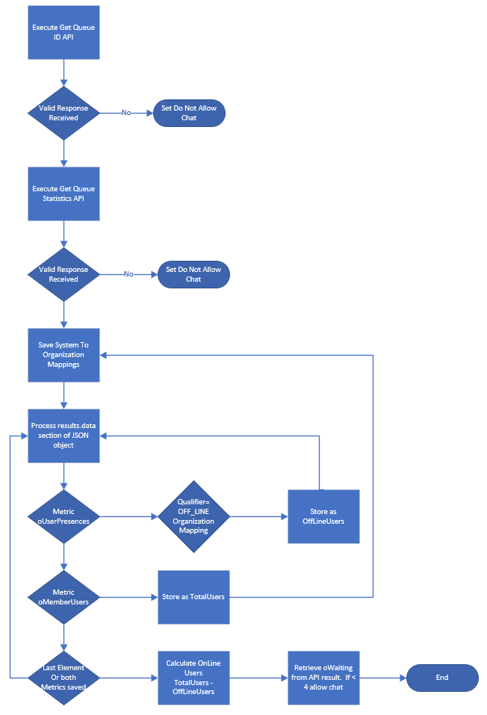

Get Schedule Group ID
To determine if the contact should be open based on operating hours, a series of API’s will be executed to retrieve the Schedule Group and the associated Schedules. The Schedules will include Open hours and Holiday days.

HTTP Request
GET /api/v2/architect/schedulegroups?pageNumber=1&pageSize=25&name=WebMessaging HTTP/1.1
Host: api.usw2.pure.cloud
Authorization: Bearer **************************************************************************************
Content-Type: application/json

JSON Input
N/A

JSON Output
{
"entities": [
{
"id": "0a33383d-3fbe-43fa-a22c-2b9c7388ed3c",
"name": "WebMessaging",
"division": {
"id": "b1e0c0e5-450d-4c5f-8eee-6b59c2e68f6e",
"name": "Concierge",
"selfUri": "/api/v2/authorization/divisions/b1e0c0e5-450d-4c5f-8eee-6b59c2e68f6e"
},
"version": 2,
"dateCreated": "2023-08-29T15:50:55.059Z",
"dateModified": "2023-09-14T14:53:01.878Z",
"modifiedBy": "6c74e21f-7d65-4b0e-b16a-326d3aba09ba",
"state": "active",
"timeZone": "America/Los_Angeles",
"openSchedules": [
{
"id": "259d198f-fb51-4068-91be-b10017b426b4",
"name": "Concierge_Generic",
"selfUri": "/api/v2/architect/schedules/259d198f-fb51-4068-91be-b10017b426b4"
}
],
"closedSchedules": [],
"holidaySchedules": [
{
"id": "a2f76ebd-3cb0-48e7-ad94-a7d414b0e588",
"name": "HOL - labor day",
"selfUri": "/api/v2/architect/schedules/a2f76ebd-3cb0-48e7-ad94-a7d414b0e588"
},
{
"id": "1d405171-b460-46f5-9377-1c3d78ec9d45",
"name": "HOL- New Year",
"selfUri": "/api/v2/architect/schedules/1d405171-b460-46f5-9377-1c3d78ec9d45"
},
{
"id": "30227d2f-93bf-4e19-b2c1-e97da86fbcfc",
"name": "HOL - Memorial Day",
"selfUri": "/api/v2/architect/schedules/30227d2f-93bf-4e19-b2c1-e97da86fbcfc"
},
{
"id": "0276bf59-4255-4f80-a5d6-97f48cc6f1d5",
"name": "HOL - After Thanksgiving day",
"selfUri": "/api/v2/architect/schedules/0276bf59-4255-4f80-a5d6-97f48cc6f1d5"
},
{
"id": "c691ac39-e3b0-40f6-a1da-a9eee44f382e",
"name": "HOL - Christmas Evening",
"selfUri": "/api/v2/architect/schedules/c691ac39-e3b0-40f6-a1da-a9eee44f382e"
},
{
"id": "7b3f7067-0391-4bf1-a337-39ae5947bea9",
"name": "HOL - Presidents' Day",
"selfUri": "/api/v2/architect/schedules/7b3f7067-0391-4bf1-a337-39ae5947bea9"
},
{
"id": "324dd600-27fe-4b77-b801-35bf11cd6736",
"name": "HOL - Christmas",
"selfUri": "/api/v2/architect/schedules/324dd600-27fe-4b77-b801-35bf11cd6736"
},
{
"id": "9ed50adb-3cd9-4547-95ad-22f7628bbf4b",
"name": "HOL - Juneteenthday",
"selfUri": "/api/v2/architect/schedules/9ed50adb-3cd9-4547-95ad-22f7628bbf4b"
},
{
"id": "6b80f82e-2219-4b66-b424-2e9a96b2033d",
"name": "HOL - Thanksgiving day",
"selfUri": "/api/v2/architect/schedules/6b80f82e-2219-4b66-b424-2e9a96b2033d"
},
{
"id": "b2f5bbd1-f20e-4bc0-bc24-ac85e7c05eaf",
"name": "HOL - Independence day",
"selfUri": "/api/v2/architect/schedules/b2f5bbd1-f20e-4bc0-bc24-ac85e7c05eaf"
}
],
"edgeUpdateSchedules": [],
"selfUri": "/api/v2/architect/schedulegroups/0a33383d-3fbe-43fa-a22c-2b9c7388ed3c"
}
],
"pageSize": 25,
"pageNumber": 1,
"total": 1,
"firstUri": "/api/v2/architect/schedulegroups?pageSize=25&pageNumber=1",
"lastUri": "/api/v2/architect/schedulegroups?pageSize=25&pageNumber=1",
"selfUri": "/api/v2/architect/schedulegroups?pageSize=25&pageNumber=1",
"pageCount": 1
}

Get Schedule(s)
Each Open Schedule and Holiday Schedule will be retrieved, and the hours used to determine the status of the contact center. If any of the Holiday schedules are in the current timeframe, the contact center is closed. If the Open Schedule is in the current timeframe, then the contact center is open. NOTE: The selfUri above can be used directly to access each schedule listed. The time zone in the schedule group should be used during the evaluation of each of the schedules.

HTTP Request
GET /api/v2/architect/schedules/259d198f-fb51-4068-91be-b10017b426b4 HTTP/1.1
Host: api.usw2.pure.cloud
Authorization: Bearer *********************

JSON Input
N/A

JSON Output
Sample output for normal open schedule from the schedule group
{
"id": "259d198f-fb51-4068-91be-b10017b426b4",
"name": "Concierge_Generic",
"division": {
"id": "b1e0c0e5-450d-4c5f-8eee-6b59c2e68f6e",
"name": "Concierge",
"selfUri": "/api/v2/authorization/divisions/b1e0c0e5-450d-4c5f-8eee-6b59c2e68f6e"
},
"version": 3,
"dateCreated": "2023-08-29T15:23:45.930Z",
"dateModified": "2023-08-29T16:14:59.122Z",
"modifiedBy": "6c74e21f-7d65-4b0e-b16a-326d3aba09ba",
"createdBy": "6c74e21f-7d65-4b0e-b16a-326d3aba09ba",
"state": "active",
"modifiedByApp": "public-api-v2/7251 (i-0bff2a50042a042cf)",
"createdByApp": "public-api-v2/7251 (i-0403ec41d1a7c6ff6)",
"start": "2023-08-28T07:00:00.000",
"end": "2023-08-28T19:00:00.000",
"rrule": "FREQ=WEEKLY;INTERVAL=1;BYDAY=MO,TU,WE,TH,FR",
"referencedType": "IVRConfig",
"selfUri": "/api/v2/architect/schedules/259d198f-fb51-4068-91be-b10017b426b4"
}

When each schedule is retrieved the interval should be compared to the current day of the week from the BYDAY string that is returned. If the day of the week is equal to the current day, then check the time of day to ensure that it’s between the start and end time in the schedule.
The “rrule” parameter values are based on the iCalendar recurrence rules. Details about this rule can be found at https://icalendar.org/iCalendar-RFC-5545/3-8-5-3-recurrence-rule.html.

Medicare Sales

BUSINESS CONTEXT
Today, Medicare sales engagement is heavily reliant on voice channels, which can create friction, increase wait times, and miss opportunities to engage digitally savvy prospects earlier in their decision journey.
This integration enables Sales Chat as a digital sales channel on the Medicare shopping experience, allowing prospective members to connect with licensed Medicare sales agents in real time. The capability is designed to support sales driven conversations only, ensuring that member service inquiries are appropriately routed to Customer Service while qualified prospects are guided toward plan selection and enrollment.

Requirements
Provide the users with the ability to initiate a chat 24/7 but only have them access First line responders during working hours.
The Medicare Exploration site will display a message/chat icon launcher consistent with the pattern used on the Member Portal (replicate the “message icon” trigger pattern).
When the user clicks the message icon, the site will present the chat experience (or the appropriate availability state — see Availability section).
The chat entry point should be available on eligible pages as defined by the business (e.g., across Medicare exploration).
Working hours are as follows: Monday to Friday 9:00 – 16:00
If the user accesses the chat outside of service hours, please display the following message: Our agents aren’t available right now, but we’re still here to help
Required fields must be clearly indicated.
Basic validation must be applied (e.g., valid phone number format).
CONCURRENT CHAT CAPABILITY
- Provide Direct Sales agent with the ability to only handle 1 chat at a time.
- Create the ability for admins to add/increase capacity of chats for any agents.
- When agent is in active chat:
- Maintain a separate Call & Chat queue.
CALL MANAGEMENT:
- Having chats in the queue should not disrupt the Direct Sales agent’s call queue.
- Chats should not block any inbound calls unless explicitly desired. The inbound calls will be tagged with a higher priority than chats. This will ensure that the calls are given the first opportunity to be answered. The chat conversation score will eventually surpass the score of new inbound calls and be delivered. See https://help.genesys.cloud/articles/specify-routing-settings/ for details on Genesys routing prioritization.
CHAT TRIAGE:
Any chat requests coming on the Medicare microsite should be received by the following:
- Enrollment coordinator
- Contingent worker.
First line responders should have the ability to either forward the chats to Direct Sales Agents or Customer Service Reps.
- Prospect-related queries should be forwarded to Direct Sales Agents
- Member-related queries should be forwarded to CSR’s. NOTE: this will be a training issue as the customer experience CSRs and used to handling only authenticated chats from members.
- First-line responders should know which Agents are available for a chat.
- They should not be able to forward a chat to anyone occupied with a call or chat. Transfers will only occur to a queue, Genesys will manage the delivery of the chat based on the queuing prioritization.
QUEUE MANAGEMENT:
Provide Direct Sales Agents the ability to choose between a chat or call which are both in queue.
Chat should not disrupt the current call queue that the Direct Sales agent has
Provide First Line responders/Direct Sales Agents with the ability to move chats to another Agents queue only if:
- They are not occupied with another chat
- Call queue is not at 100% capacity.
- As an operations manager, I want Enrollment Coordinators or contingent workers to buffer incoming chats, so that DSAs are protected from non-sales inquiries
- As a Customer Service agent, I want to transfer sales-driven chats to Direct Sales, so that prospects reach the right team. The transfer will be to the direct sales messaging queue, not directly to an agent.
- As a prospective beneficiary, I want to be prompted to call if no sales agent is available, so that I still have a path to assistance
- As a prospect turning 65, I want to chat with a sales agent, so that I can understand Medicare enrollment options
- As a prospect who already reviewed plans, I want to ask follow-up questions via chat, so that I can clarify eligibility or coverage
- As a prospect experiencing plan or provider disruption, I want to connect with sales, so that I can explore new coverage
- As a site administrator, I want the ability to manually trigger the sales chat, so that chat can be offered strategically. Not available until 2027 in Genesys for Blue Shield.
- As a digital experience owner, I want chat to trigger after a user spends time on the site, so that engaged prospects are prompted. Not available until 2027 in Genesys for Blue Shield.
- As a prospect who declines chat, I want to see a phone number, so that I still have a support option. Not available until 2027 in Genesys for Blue Shield.
- As a sales agent, I want minimum required lead info collected before handoff, so that I can efficiently help the prospect
- As a marketing and sales team, I want to know how the prospect arrived at chat, so that we can track lead sources
- As a prospect, I want chat to be available during defined working hours, so that I know when support is live
- As a DSA, I want flexibility to handle calls or chats without disrupting call queues, so that service levels are maintained
- As a sales agent, I want to triage chats, so that I can determine best handling approach
- As an operations team, I want defined behavior when queues are full, so that demand is managed gracefully. What parameters will be required for this “queue full” determination?
- As an operations manager, I want to limit concurrent chats per agent, so that service quality is maintained

Transfers
Chats will only be transferred directly to another queue.
Agents will be able to transfer to the customer experience, direct sales, and broker queues.

Data collection During Hours
When the user tries to access the chat please let the user go in the following flow

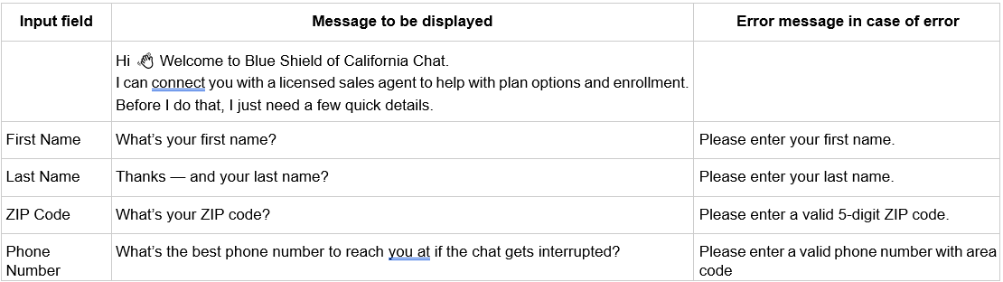
Once the user provides all the information add prospect to sales coordinator queue and display the following message:
”Thanks, [First Name] — I’m connecting you with a Medicare sales agent now.”
The phone number entered will be used to screenpop the same screen as an inbound call. Genesys will not directly integrate with Salesforce APIs to write contacts to Salesforce.

Afterhours Processing
Working hours are as follows: Monday to Friday 9:00 – 4:00
If the user accesses the chat outside of service hours, please display the following messages:
“Chat Is Currently Unavailable, our licensed sales agents aren’t available right now, but we’re still here to help. Please use the link below to book an appointment with a licensed sales agent at a time that works best for you.”
CTA should be: “Book an appointment with a licensed sales agent”
CTA Link: https://bookings.cloud.microsoft/book/MedicarePlanOptionsDiscussion@blueshieldca.com/
We’re here to help
Genesys cannot detect if the URL above is clicked. Messaging should be written to accommodate one push of closed information to the prospect.
Do not request any input information during afterhours.
The unavailable-state experience must be reusable across multiple unavailability conditions (after-hours, queue full, no enrollment coordinator available, no sales agent available) so the user sees one consistent fallback experience.
Please follow the same behavior if the queue is full and when enrollment coordinators and sales agents are not available

Web Portal Integration
The standard Genesys Web Messaging Widget will be used to integrate the Medicare portal with Genesys Cloud.

Web Messenger Sample JavaScript
A unique JavaScript code snippet will be generated once the web messaging configuration is completed. Below is a sample of a non-authenticated messaging implementation. The “Database.set” function must be used to pass a message type flag to identify this chat type to Genesys. This is not a part of the default JavaScript snippet and must be added to the code.
<script type="text/javascript" charset="utf-8">
(function (g, e, n, es, ys) {
g['_genesysJs'] = e;
g[e] = g[e] || function () {
(g[e].q = g[e].q || []).push(arguments)
};
g[e].t = 1 * new Date();
g[e].c = es;
Genesys("command", "Database.set", { messaging: { customAttributes: { MessageType: “MedicareSales”}});
ys = document.createElement('script'); ys.async = 1; ys.src = n; ys.charset = 'utf-8'; document.head.appendChild(ys);
})(window, 'Genesys', 'https://apps.usw2.pure.cloud/genesys-bootstrap/genesys.min.js', {
environment: 'usw2',
deploymentId: TBD'
});
</script>

The API integration used for the Member, Provider, and Broker portals is not necessary for the Medicare Sales chat.

Acceptance Criteria

Unavailability
Scenario | Given | When | Then | Notes
1 | Direct Sales Agent is logged into the Genesys platform | When a chat is routed to the agent | Then the agent can accept and handle one (1) active chat at a time
2 | Direct Sales Agent is logged into the Genesys platform | When an additional chat attempt is made while the agent is already handling a chat | Then the additional chat remains in the chat queue
3 | Direct Sales Agent is logged into the platform and available for calls | When one or more chats are active or waiting in the chat queue | Then the agent remains available to receive inbound calls per existing call routing rules and then chat activity does not remove the agent from the call queue.
4 | Incoming calls are present in the Direct Sales call queue | When chats are also present in the chat queue | Then incoming calls are routed based on existing call queue priority and rules
5 | A Direct Sales Agent has reached maximum configured chat capacity | When a new chat is initiated by a  Medicare prospect | Then the chat is queued or routed to another eligible agent and Then the system prevents additional chats from being assigned to the agent beyond the allowed threshold.

Chat and Call Management
 | Scenario | Given | When | Then
1 | Chat can be initiated at any time | The user is on a page where  Sales Chat is enabled | The user clicks the chat entry point | The chat experience opens regardless of time of day.
2 | Live responder access is limited to working hours | The user opens chat during working hours | The system checks responder availability | The user may proceed toward live responder handling only during Monday–Friday, 9:00 AM–4:00 PM.
3 | After hours unavailable message is shown | The user opens chat outside service hours | The availability check is performed | The chat window displays the unavailable message: “Chat Is Currently Unavailable … Please use the link below to book an appointment with a licensed sales agent at a time that works best for you.”
4 | Booking CTA is displayed in after-hours state | The unavailable message is displayed | The after-hours state is rendered | The CTA text shown is “Book an appointment with a licensed sales agent”
5 | Booking CTA uses the provided URL | The unavailable message is displayed | The user selects the CTA | The CTA directs the user to Book an appointment with a licensed sales agent
6 | Confirmation message is shown after CTA click | The unavailable message and  CTA are displayed | The user clicks the booking CTA | The chat window displays: “We’re here to help” and*“A licensed sales agent will follow up with you to provide personalized support.
7 | No data collection is shown in after-hours state | The user accesses chat outside service hours | The unavailable state is displayed | No input fields, intake questions, or sequential prompts are shown
8 | Queue-full state uses the same unavailable experience | The user opens chat during a time when the queue is full | The system determines that queue capacity has been reached | The same unavailable message and booking CTA are displayed instead of placing the user into a waiting state. Queue-capacity and booking fallback were explicitly discussed.
9 | No enrollment coordinator available uses the same unavailable experience | The user opens chat during working hours | The system determines that no enrollment coordinators are available | The same unavailable message and booking CTA are displayed. The meetings discussed agent-unavailability scenarios and booking fallback.
10 | No sales agent available uses the same unavailable experience | The user opens chat during working hours | The system determines that no sales agents are available | The same unavailable message and booking CTA are displayed. The meetings discussed no-agent-available scenarios redirecting users to booking
11 | No user information is requested in any unavailable state | The user is in an unavailable state (after-hours, queue full, no coordinator, or no sales agent available) | The unavailable experience is shown | The system does not request first name, last name, phone number, ZIP code, or any other input
12 | Unavailable experience is consistent across all unavailable scenarios | The user encounters any unavailable scenario | The fallback experience is displayed | The header, body copy, CTA label, CTA URL, and postclick confirmation message are consistent across all unavailable scenarios

Chat Trigger
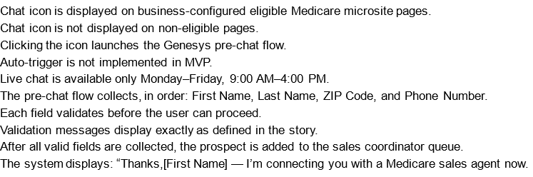

Queue Management
ACCEPTANCE CRITERIA:
- Given that an agent is unavailable, when a chat is routed, then the agent does not receive the chat.
- Given an agent becomes available, when there are queued chats, then the agent receives the next eligible chat.
- Given no agents are available across all eligible queues, when a chat request is made, then the user is presented with an alternative support option. Genesys will only check the triage queue to determine if agents are available.
- Given a system interruption, when chat routing fails, then the user receives a clear error or fallback message (phone number). Need to define “system interruption”. If the user loses internet connection, no additional prompting is possible from Genesys.

Bulk Scheduled Trigger/Queue Activation Process Automation
Blue Shield (BSC) currently performs many Bulk Scheduled Configuration modifications to Genesys Cloud using externally housed/executed Scripts. One such example are the daily “TT Agent Activation” Scripts that execute daily to “Join” (Activate) and “UnJoin” (Deactivate) Teletech Agents from several CE Queues. That process uses several Genesys APIs to look up Queue information, finding Agents based on their Home Division assignment, and joining/unjoining them from Queues as applicable.
Due to a Q2 Genesys Cloud Feature Release, “Scheduled Triggers” are now capable of recreating this externally-scheduled/executed Process entirely within the Genesys environment when used in combination with the existing Architect Workflow type.
The BSCA Application Development Team provided the technical details of the “Agent Activation” scripted process, which was recreated and tested wholly in the Genesys DEV environment.

Acceptance Criteria
Using Genesys Workflows and Scheduled Triggers, recreate the “Agent Activation” Scripted Process provided by the BSCA Application Development Team for the scheduled, bulk modification of PROD Queues for TT Agents.

Technical Solution Specifics

Member Queue Management
The solution is comprised of:
- 1 new Genesys Data Table “AUTO_BulkQueueManagement”
- 2 new Genesys Workflows:
  - “BSC_Join_Queue_Members”
  - “BSC_UnJoin_Queue_Members”
- 3 existing Genesys Data Actions:
  - “Get Data Table ID by Name”
  - “Get Data Table All Rows”
  - “Get Queue ID by Name”
- 2 new Genesys Data Actions:
  - “Get Queue Members with Division by Page”
  - “Join Queue Members”
- 2 new Scheduled Triggers:
  - “Bulk Agent Queue Activation”
  - “Bulk Agent Queue Deactivation”

Data Table
The new Data Table “AUTO_BulkQueueManagement” is used to house two data points that feed into the Workflows, “QueueName” – The Target Queue from which to Activate/Deactivate Agents, and “AgentDivision” – The Division name from which to filter Queue Agents to perform the bulk action against. There should be 1 Data Table Row created for each Queue, for each Division. For example, removing Agents from one Division from one Queue would require 1 Data Table Row. Removing Agents from one Division from two Queues would require 2 Rows. 2 Divisions from 3 Queues, 6 Rows, and so on.

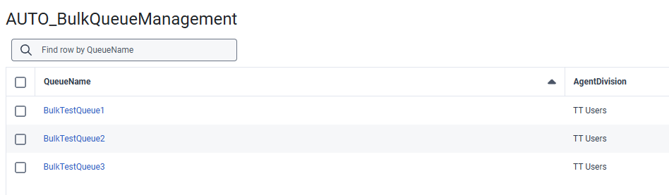

Workflows
Two separate Workflows were created to be triggered at different times which are nearly identical, with the only difference being the Data Action which performs the Queue Member modification, either Joining/Activating or Unjoining/Deactivating as applicable. Below is an overview of the Workflow process:
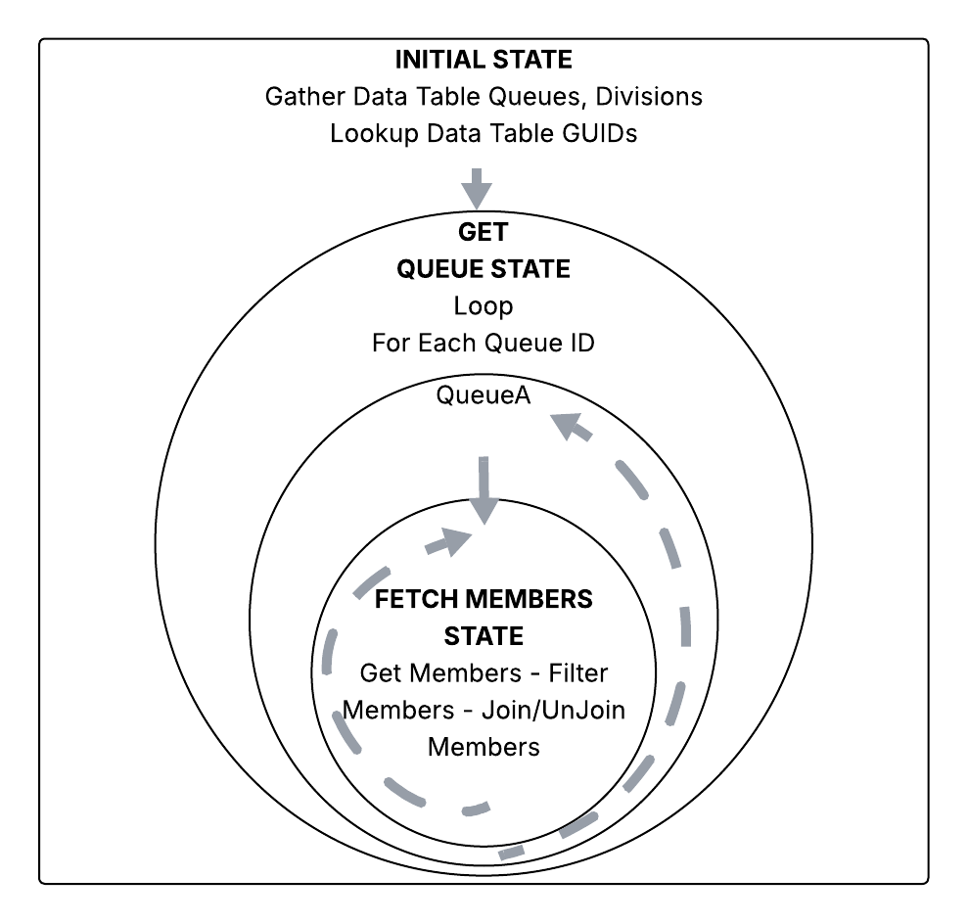
**Note: Within the Workflow, all Variables are Dynamic rather than Static so that scalability is supported and, as more Queues and/or Divisions require manipulation, no Workflow modifications should be necessary.

Scheduled Triggers
Currently, Scheduled Triggers do not support passing data into the Workflow being invoked, therefore 2 Scheduled Triggers are required for this solution, each Triggering a separate Workflow. It is expected that BSCA will modify the Trigger Execution Schedule Timing as appropriate for the Queues and Divisions being modified:

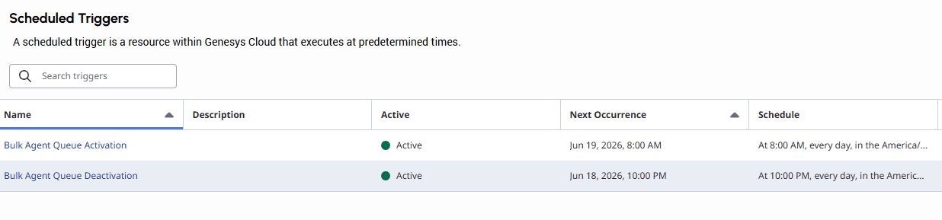

Web Messaging
Blue Shield has deployed the Genesys web messaging widget on several portals. This includes:
- Medicare Customer Care
- IFP Customer Care
- Medicare Sales
- Provider Connection
- Broker Connection
- BSC Employee Members – Sierra Generative Agent
These all use the BSC_WebMessaging_V0X callflow and digital bot flows for prompting, routing, and connectivity to Sierra. The current version of this callflow is BSC_WebMessaging_V07.

Data Actions
The following data actions are used by the callflows, workflows, or digital bot flows:
Data Action Name | Description
Create Queued Callback with Standard Data | Creates a callback for the targeted queue
Create Survey for Scoring | Creates the survey object in Genesys for later scoring
Execute Email Transcript Workflow | A Genesys workflow is used to generate the transcript email to the portal user. This data action starts the execution of the workflow.
Get Estimated Wait Time – Message | Retrieve the EWT for the targeted queue
Get Existing Callbacks | Gets a list of the current callbacks for the targeted queue
Get Interactions in Queue – Message | Get the number of interactions currently in the targeted queue
Get Microsoft Graph API Token | Retrieve a token from Microsoft OAuth for Graph email
Get Number of Agents Logged In | Get the number of agents logged into the targeted queue
Get Queue ID by Name | Retrieve the UUID of the targeted queue
Get Survey Form Information | Retrieves survey form and questions
Get-Message-Transcript | Retrieve message transcript for conversation
Score Survey from Messaging | Update survey data for the interaction
Send Agentless Email Via Microsoft Graph API | Send transcript via Microsoft Graph API

Data Tables
The following data tables are used by web messaging integration
Data Table Name | Description
BSCWebMessagingData | Stores member data from web portal
RT_DateTime | Date time configuration from routing engine. Used for time zone offset and daylight saving time
RT_TranslatePDData | Used by the routing engine and web messaging to correctly format data for display
WM_Buttons | Buttons that will be shown to the portal user to select targeting of the interaction
WM_Configuration | Configuration of menus for each group. Messaging for closed, holiday, and emergency. Queue configuration for targeting
WM_TranscriptConfiguration | Transcript email from address and workflow id configuration. Enable / disable transcript functionality

Callflows
Callflow Name | Type | Description
BSC_WebMessaging_PostAgent_V01 | Digital Bot Flow | Execution of post agent interaction with portal user.
BSC_WebMessaging_Survey_V01 | Digital Bot Flow | Execution of survey
WM__DB_GetMemberData_V07 | Digital Bot Flow | Retrieves member data from data table
WM__DB_Menus_V07 | Digital Bot Flow | Build menus from buttons table and accept input
BSC_WebMessaging_PostAgent_V01 | Inbound Message | Used to drive post agent interaction with the web portal user. Determines if an email transcript can be emailed or a survey offered
BSC_WebMessaging_Survey_v01 | Inbound Message | Driver for post agent surveys
BSC_WebMessaging_V07 | Inbound Message | Main driver callflow for prompting, routing, and Sierra connectivity
BSC_WM_EmailMessageTranscript | Workflow | Build and send email transcript

Callflow Usage
The following diagram demonstrates how the inbound message flows, digital bot flows and workflows interact:
